# **Module 7**

1. **For each consistency error in Figure 1, you should identify the consistency rule violated and suggest possible resolutions of the error.**



The following are the errors in the given ERD:

1. **Identification Dependency cardinality rule Violation:**

The cardinality of the 'Rel7' relationship near 'Entity7' should be (1, 1).

1. **Identifying relationship rule violation**

Seen at ‘Rel8’ which is an identifying relationship but none of the Entities is a Weak entity.

1. **Redundant FK rule violation:**
2. In Entity 2 having attribute of Entity 1(Attribute 1-1 primary key of Entity 1)
3. In Entity 2 having attribute of Entity 4(Attribute 4-1 primary key of Entity 4)
4. **Attribute Name rule violation:**

Entity 2 has two attributes with same name Attribute 2-1

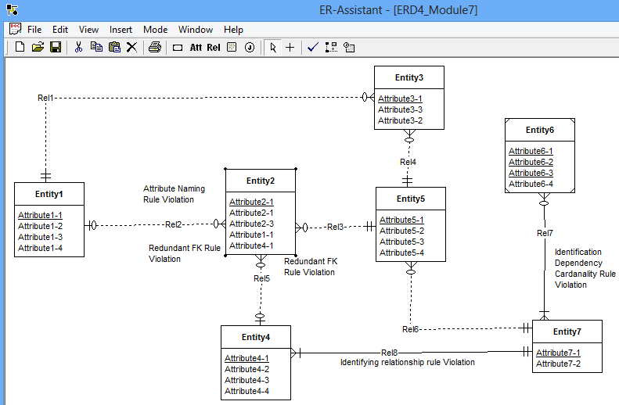

Figure 2: Showing errors listed near entities and relations

**The following list identifies possible ways to fix the diagram errors:**

* Resolution of the identification dependency cardinality rule: The problem can be resolved by changing cardinality in Entity7 of Rel7 to (1,1).
* Resolution of the identifying relationship rule: The problem can be resolved by adding one or more weak entities or making the relationship (Rel8) non-identifying.
* Resolution of the redundant FK rule: Normally the problem can be resolved by removing the redundant foreign keys (Entity2.Attribute2-1 and Entity2.Attribute4-1). If the attribute does not represent a foreign key, it should be renamed instead of removed.
* Resolution of Attribute name rule violation: Remove the extra attribute attribute 2-1 or rename it if it represent some information.

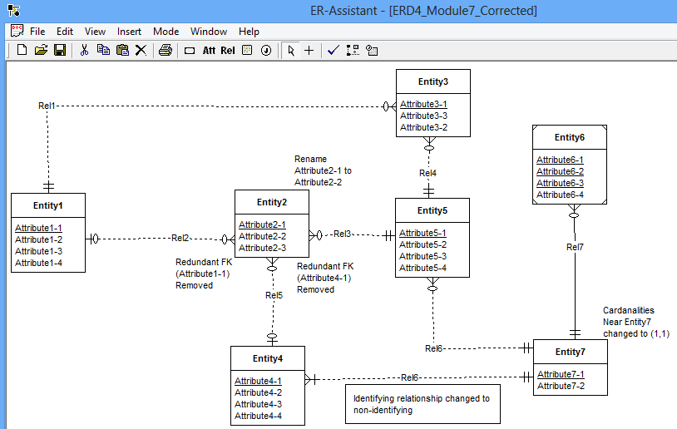

Figure 3: Errors corrected in ERD